**Word of Life: November 2020**

*Recommended dates are provided, but you are welcome to use these materials at any time!*

**Featured this Month…**

**Priorities at the Polls**

**November 1, 2020**

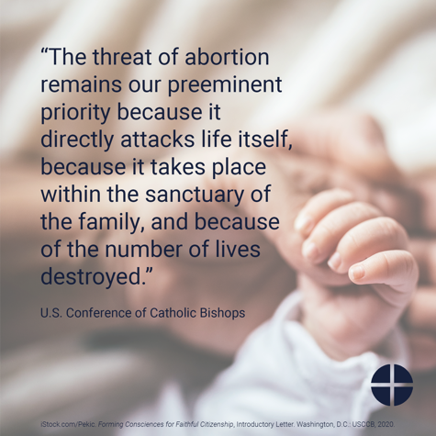**Sample Announcement**

Find out why, when considering our civic engagement as Catholics, the U.S. bishops recently affirmed, “The threat of abortion remains our preeminent priority.” [respectlife.org/priorities-at-the-polls](http://www.respectlife.org/priorities-at-the-polls)

**Image, Bulletin Insert PDF, and Word Doc**

<https://www.usccb.org/resources/priorities-polls>

**Pray for Life**

**November 2020**

**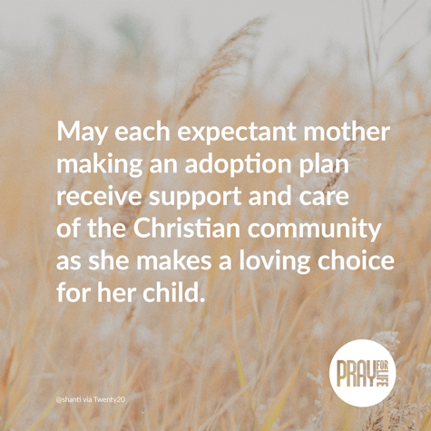***Please note: Each month’s issue is posted the first day of that month on the website below.*

**Sample Announcement**

Join this month’s prayer and action at [walkingwithmoms.com/pray-for-moms](http://www.walkingwithmoms.com/pray-for-moms)!

**Image and Prayer Guide (print version)**

<https://www.usccb.org/resources/pray-life-november-2020>

**The Solemnity of Our Lord Jesus Christ, King of the Universe   
November 22, 2020**

[Resources are being made available](http://www.usccb.org/issues-and-action/religious-liberty/christ-the-king/index.cfm) to help educate the faithful about the Solemnity of Christ the King and its connection to religious liberty.

22

**Word of Life – November 2020**

**Intercessions for Life**

|  |  |
| --- | --- |
| **November 1st**  For all Christians:  May God inspire us to be faithful citizens,  protecting the most vulnerable,  especially unborn children;  *We pray to the Lord:* | **Solemnity of All Saints** |
| **November 8th**  For all public officials, especially those newly elected: May they strive to govern with the wisdom of God,  and protect life from conception to natural death;  *We pray to the Lord:* | **Thirty-second Sunday  in Ordinary Time** |
| **November 15th**  For married couples considering adoption:  May the Holy Spirit guide their discernment,  grant them peace, and bring to fruition his holy will;  *We pray to the Lord*: | **Thirty-third Sunday in Ordinary Time** |
| **November 22nd**  On this feast of Christ the King and always:  May all recognize God as the author of life  and give thanks for His precious gift;  *We pray to the Lord:* | **The Solemnity of Our Lord Jesus Christ, King of the Universe** |
| **November 29th**  For all the faithful:  May the Lord help us build a culture of life  in vigilant expectation of His return;  *We pray to the Lord*: | **First Sunday of Advent** |

**Word of Life – November 2020**

**Bulletin Quotes**

|  |  |
| --- | --- |
| **November 1st**  When considering faithful citizenship, “the U.S. bishops have reaffirmed that ‘the threat of abortion remains our preeminent priority because it directly attacks life itself, because it takes place within the sanctuary of the family, and because of the number of lives destroyed.’”  Most Reverend Joseph F. Naumann, Chair of the USCCB Committee on Pro-Life Activities  “Priorities at the Polls” citing Introductory Letter to “Forming Consciences for Faithful Citizenship” | [Download](https://www.usccb.org/resources/rlp-20-priorities-at-the-polls-bulletin-insert.pdf) [| Read Online](https://www.respectlife.org/priorities-at-the-polls) |
| **November 8th**  “We know earthly death is not the end, but rather the door through which we must pass to gain eternal life. Because of our belief and hope in the Resurrection, we can face death not with fear, but with preparation… We prepare for eternal life by choosing to love and follow God now, in our daily lives and decisions.”  USCCB Secretariat of Pro-Life Activities,  “Catholic Considerations for Our Earthly Passing”  respectlife.org/end-of-life-considerations | [Order](http://store.usccb.org/Catholic-Considerations-for-Our-Earthly-Passing-p/c1744.htm) | [Download](https://www.usccb.org/about/pro-life-activities/respect-life-program/2017/upload/rlp-17-end-of-life-flyer-color-secure.pdf)  [Online](https://www.usccb.org/about/pro-life-activities/respect-life-program/2017/upload/rlp-17-end-of-life-flyer-color-secure.pdf) |
| **November 15th**  “We can’t imagine loving a child whom we conceived more than we love Andrew. It is amazing how he fits our personalities so well… Adopting Andrew has made us more aware of God’s power and of his love for us. We realize that he always has a perfect plan for our lives.”  USCCB Secretariat of Pro-Life Activities,  “An Adoption Love Story” (respectlife.org/adoption-love-story) | [Order](http://store.usccb.org/product-p/c1445.htm) | [Download](https://www.usccb.org/about/pro-life-activities/respect-life-program/2014/upload/An-Adoption-Love-Story-RLP2014-Bulletin.pdf)  [Online](https://www.usccb.org/about/pro-life-activities/respect-life-program/2014/upload/An-Adoption-Love-Story-RLP2014-Bulletin.pdf) |
| **November 22nd**  “The right to religious freedom has its foundation in the very dignity of the human person.”  Pope Paul VI, *Dignitatis humanae* (*Declaration on Religious Freedom*), 2.  © 1965 Libreria Editrice Vaticana. Used with permission. All rights reserved. | Index  [Read Online](http://www.vatican.va/archive/hist_councils/ii_vatican_council/documents/vat-ii_decl_19651207_dignitatis-humanae_en.html) |
| **November 29th**  “Having received the gift of the Gospel of Life, we are the people of life and a people for life. It is our duty to proclaim the Gospel of Life to the world. To proclaim Jesus is to proclaim life itself. Gratitude and joy at the incomparable dignity of the human person impel us to bring the Gospel of life to the hearts of all people and make it penetrate every part of society.”  USCCB Secretariat of Pro-Life Activities “The Gospel of Life: A Brief Summary”  respectlife.org/gospel-of-life-summary | [Download](https://www.usccb.org/resources/rlp-20-bulletin-insert-ev-summary_0.pdf) | [Read Online](https://www.respectlife.org/gospel-of-life-summary)  [Online](https://www.respectlife.org/gospel-of-life-summary) |

**Word of Life - November 2020**

**Bulletin Art**

*You are welcome to use these and other downloadable images from the online* [**Respect Life image gallery**](https://www.respectlife.org/respect-life-image-gallery)*, provided they are not altered in any way, other than the size. Thank you!*

**Sunday, November 1st, 2020**

**Sample Announcement**

Find out why, when considering our civic engagement as Catholics, the U.S. bishops recently affirmed, “The threat of abortion remains our preeminent priority.” [respectlife.org/priorities-at-the-polls](http://www.respectlife.org/priorities-at-the-polls)

**Image, Bulletin Insert PDF, and Word Doc**

<https://www.usccb.org/resources/priorities-polls>

**Sunday, November 15th, 2020**

* 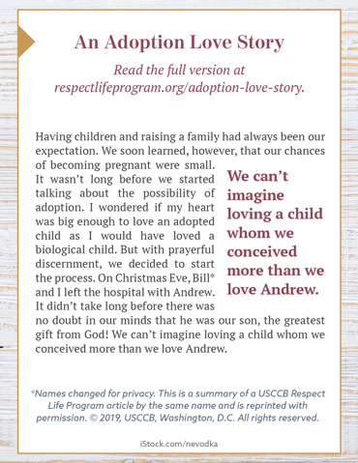**Image (Color):** [English](https://static.wixstatic.com/media/c138fd_501830b028e94988a3194a0cf2f25c6b~mv2_d_1275_1650_s_2.png/v1/fill/w_1275,h_1650/rlp-19-bulletinboxes-adoption-love-story.png) | [Spanish](https://static.wixstatic.com/media/c138fd_450c9454c6c14392a21ec93eea9caee2~mv2_d_1275_1650_s_2.png/v1/fill/w_1275,h_1650/rlp-19-bulletinboxes-adoption-spn.png)
* **Image (Grayscale):** [English](https://static.wixstatic.com/media/c138fd_b885ed7c069f4b1793b1b0683a9ceeb7~mv2_d_1275_1650_s_2.png/v1/fill/w_1275,h_1650/rlp-19-bulletinboxes-adoption-love-story-bw.png) | [Spanish](https://static.wixstatic.com/media/c138fd_f637ad169153461e989ff8d1cba3a048~mv2_d_1275_1650_s_2.png/v1/fill/w_1275,h_1650/rlp-19-bulletinboxes-adoption-spn-BW.png)
* **Quote Source:** [An Adoption Love Story](https://www.respectlife.org/adoption-love-story) (See bottom of the [webpage](https://www.respectlife.org/adoption-love-story) for additional formats.)

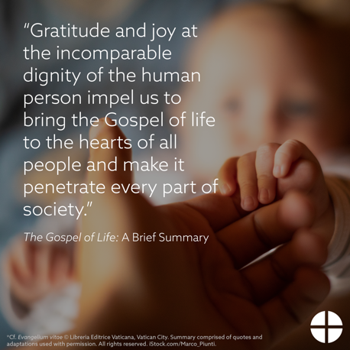**Sunday, November 29th, 2020**

**Online Article:** [*The Gospel of Life:* A Brief Summary](https://www.respectlife.org/gospel-of-life-summary)

**Image, Bulletin Insert PDF, and Word Doc**

<https://www.usccb.org/resources/gospel-life-brief-summary>